bgRFC Framework in SAP

Table of Contents

What is bgRFC?......................................................................................3
bgRFC Configaration..............................................................................5
bgRFC Programming............................................................................17
bgRFC Debugging.................................................................................20
bgRFC Monitoring................................................................................22

- What is bgRFC?
The bgRFC allows applications to record data that is received later by a called application. When the data is received, we must ensure that the data was transferred to the receiver either once only in any order (transactional) or once only in the order of creation (queued).

With the bgRFC, therefore, the asynchronies between the caller and the called application can result in the following advantages:
- Within an SAP system (same system ID, same client).
Decoupling and (potentially) parallelization are possible. The load is spread across the available application servers for this system.
This bgRFC scenario is known as an inbound procedure.
- Between two remote SAP Systems
Decoupling and therefore the physical segmentation of an application or a business scenario are possible. As a result of the asynchronies, differences in the key features of the application servers for the called and calling applications can be balanced out. The recording is done in the calling system.
This scenario is an outbound procedure.
- Both procedures can be combined in an out-in procedure.
Here we can take advantage of all the optimization options. If we choose this option, however, the data is recorded twice, once for the caller (outbound processing) and once for the called application (special type of the inbound procedure). This results in additional load for both database and for the application server due to the scheduler.
Restrictions
Combined use of the bgRFC with tRFC and qRFC in a single destination is not possible. However, for each destination we can define which communication type we want to use.
Architecture
The classic qRFC model detects the dependencies among the individual units only when the data is processed by the RFC scheduler. For each destination, the outbound scheduler starts a scheduler that processes the data for this destination.
The schedulers run on each destination only for a limited period of time to ensure processing is consistent for all destinations. For this reason, the scheduler must determine the sequence again every time before it processes a destination.
In contrast, with the bgRFC, the dependencies are determined when the data is stored. In doing so, the RFC scheduler can find all units that can be executed instantly with minimum effort and all dependencies are detected only once. The additional effort when storing the data is compensated to a large extent by efficient algorithms and optimizations in the database design.
Gateway
The gateways, another potential source of bottlenecks, have also been optimized. The new concept regulates the maximum number of outbound schedulers that are allowed to run at the same time on an application server, and the maximum number of connections that all RFC schedulers can use. This limitation prevents the local gateway from becoming overloaded.
The gateways of the destinations are protected from overload as well by making the number of parallel outbound schedulers for each sender system and their maximum number of connections configurable.
Effects on Performance
The improvements implemented with the new bgRFC design become noticeable primarily under high-load conditions when there are many dependent units for each destination. For the first time, a linear logarithmical scalability (dependent on the system capacity) is possible for RFC data processing.
The transactional behavior of the queuing function does not allow for significant savings when an individual unit is being processed, but the application of more or faster hardware produces more noticeable results in throughput. The limiting factors are the performance of the database and the processing speed of the units.
A new API also contributes to an optimized procedure. Redundant functions have been removed and some of the limitations of the old API no longer apply. This has resulted in a smoother and more efficient concept that will reduce time and effort for both support and development teams.

ii) bgRFC Configuration
1. Creation of Supervisor Destination: On the Define Supervisor Dest. Tab in transaction SBGRFCCONF, we can define a supervisor destination for bgRFC processing. The supervisor destination gets the configuration settings for the bgRFC scheduler and starts or stops the schedulers as required on each application server.
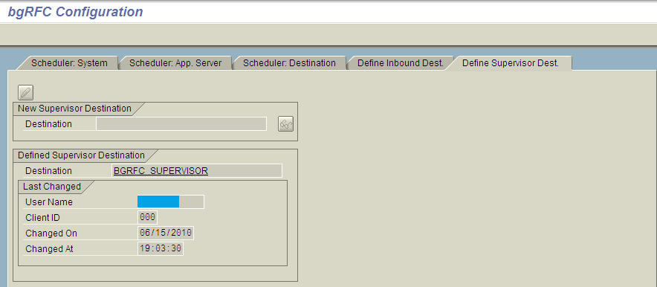
This is a mandatory step because the bgRFC can only function if a supervisor destination has been defined.

Prerequisites
We have used transaction SM59 to define the supervisor destination as an RFC destination. This destination must be defined as either an ABAP connection or a logical connection. The following prerequisites must be met.
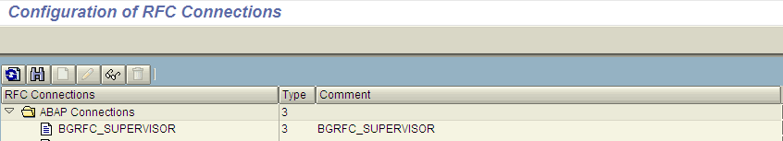
ABAP Connection
No load balancing can be defined.
No system number can be entered.
No server can be entered.
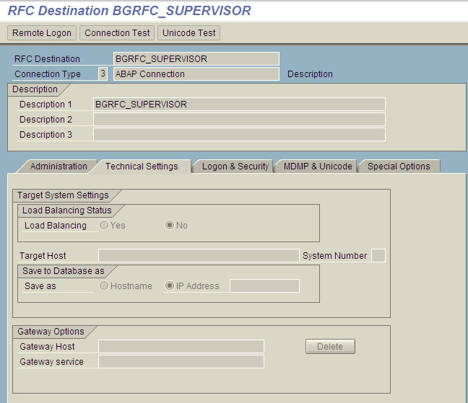

A user, password, and client must be entered for both connection types. Please refer the attached screenshots.
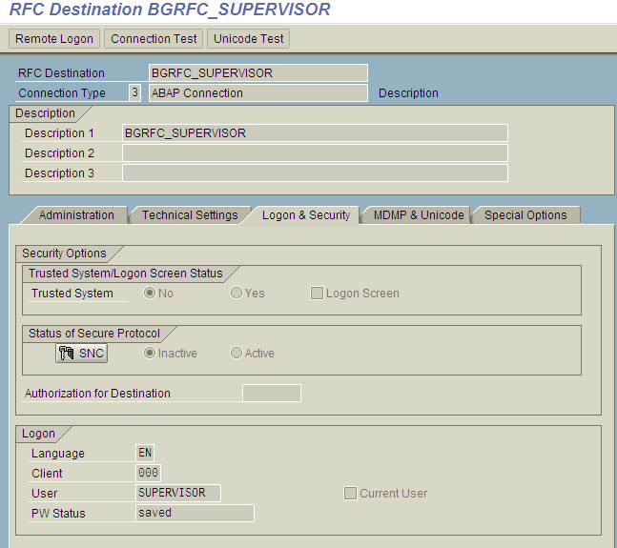
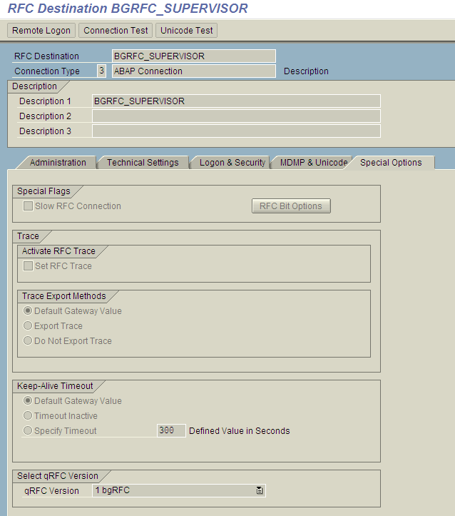

2. Creation of destination: We have to create inbound/outbound destination name based on the requirement.
a) Creation of Inbound destination: On the Define Inbound Dest. Tab page in the transaction SBGRFCCONF, we can maintain a separate inbound destination for each application. In the attached screenshot 6 inbound destinations is maintained. This is also a mandatory step to create any inbound bgRFC. Logon/server group can be defined using transaction RZ12. For each inbound destination we can define separate server group also by clicking on the each destination name. Please refer the attached screen shot for all other settings.
All the settings and activities related to the transaction SBGRFCCONF is BASIS related activity so before creating/configuring any bgRFC please consult with BASIS team.
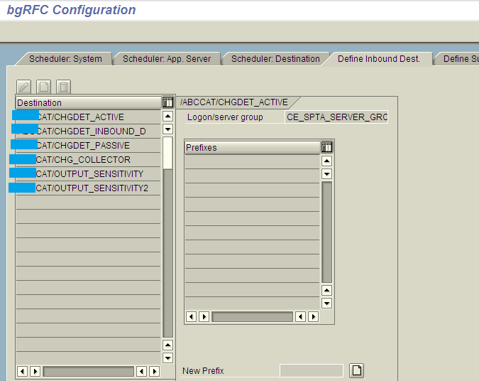

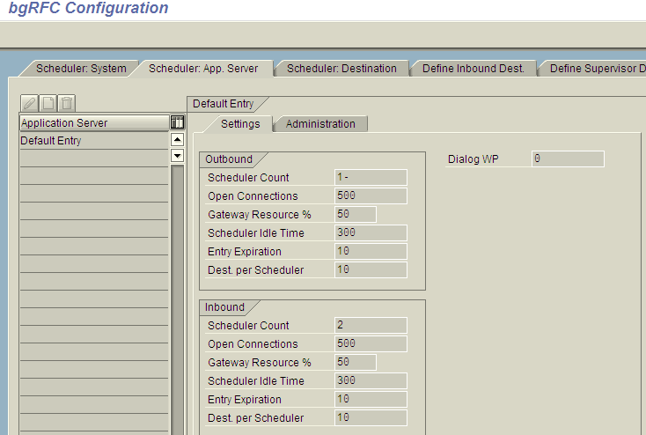
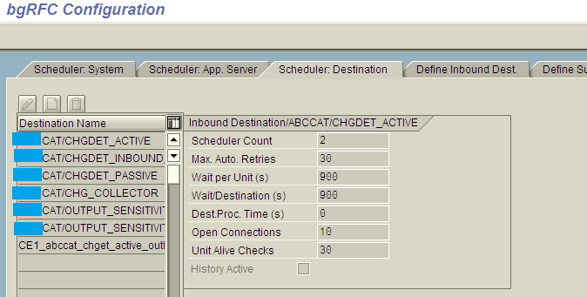

b) Creation of Outbound destination: We can create outbound destination using transaction SM59. Creation of outbound destination in SM59 is normal like any of the destination creation. Please refer the below screenshot for reference.
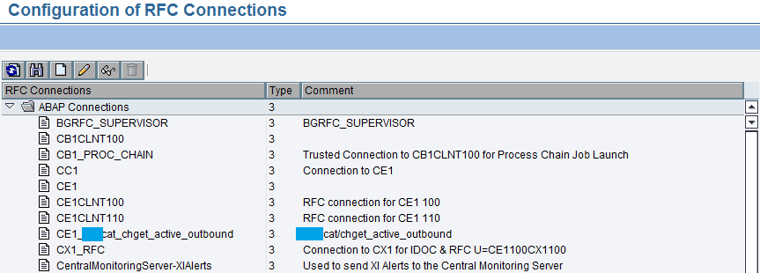
We have created outbound destination CE1_xxxcat_chget_active_outbound under ABAP Connections. For this destination we have to maintain the necessary target destination IP, system no etc. Please refer all the below screenshots for detailed settings in each tab.
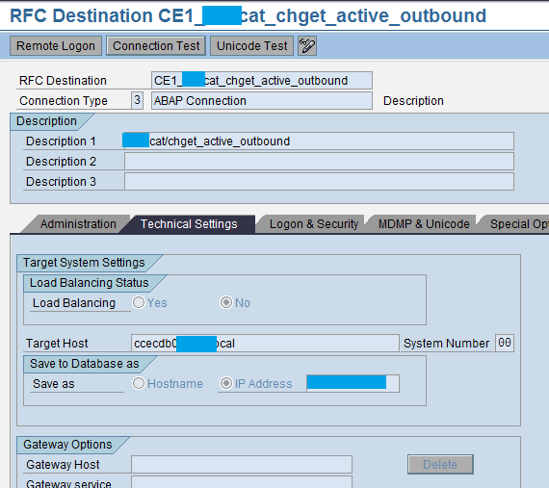

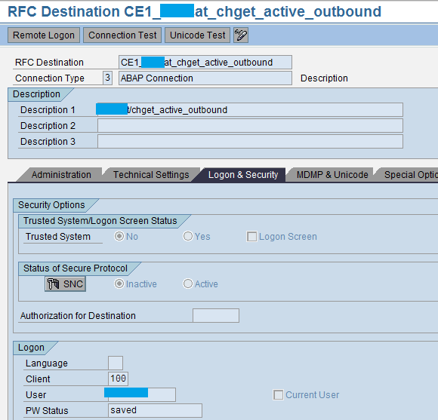
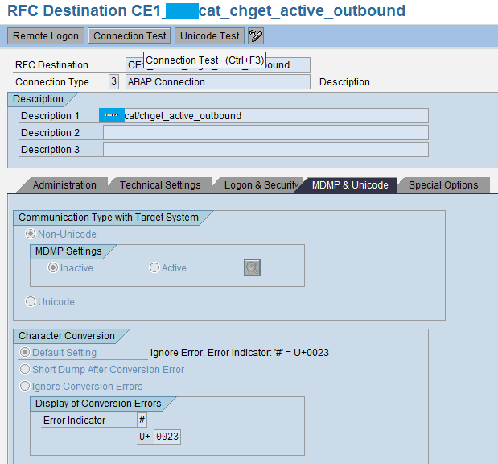
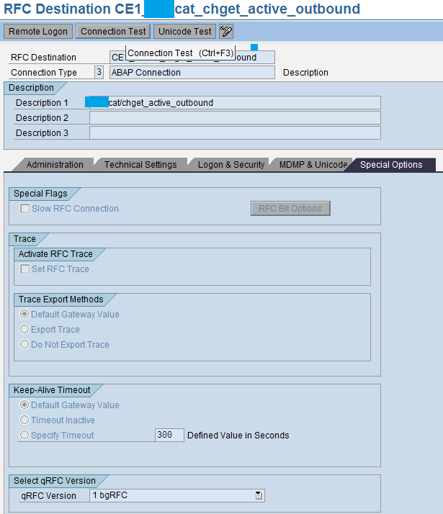

After creation of the outbound destination in SM59 we have maintain this destination in SBGRFCCONF transaction. We have to maintain the destination in Scheduler: Destination tab of transaction SBGRFCCONF. Please refer the below screenshot.
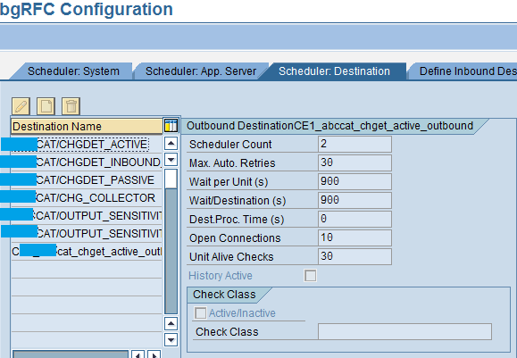

    - bgRFC Programming
After the entire configuration now let’s talk about the programming.
1. Creation of unit: We have to create one bgRFC unit by taking the reference from the configured inbound / outbound destination name. Destination objects can be requested using the class methods from the class CL_BGRFC_DESTINATION_OUTBOUND for the outbound and the class CL_BGRFC_DESTINATION_INBOUND for the inbound. We have to use method CREATE of the above mentioned class to create a destination object. Please see the below example of how to create an inbound destination object.
Pass any of the configured inbound destination name in the below mentioned variable.
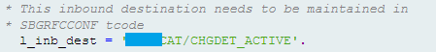
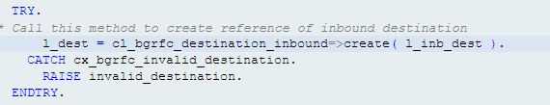

After creation of the destination object it is time to create a bgRFC unit. bgRFC unit can be two types like tRFC unit or qRFC unit. We have to use method CREATE_TRFC_UNIT to create a tRFC unit and method CREATE_QRFC_UNIT to create a qRFC unit. Please refer the below screenshot for example.
Here L_DEST is created at the previous step. We have to create a tRFC unit for that destination object. We can also define some delay during creation of the bgRFC unit to handle passive data changes but it is some advanced requirement and not in the scope of this bgRFC document.
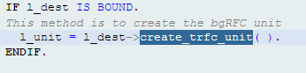
To create a qRFC unit we just have to call CREATE_QRFC_UNIT method instead of CREATE_TRFC_UNIT method.
2. Calling a function module: After creation of the unit we have to call any function module in background. The new syntax for calling a function module for background processing (previously done using IN BACKGROUND TASK) is as follows:
CALL FUNCTION ‘function_name’
IN BACKGROUND UNIT unit
EXPORTING …
Inside the calling function module we have to write our required logic which we want to process in background (e.g. Update a table). Please refer below screenshot for calling of a function module.
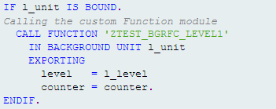
In the above example the function module is called in background using the created unit. In the exporting parameter we can define whatever we want to send in the function module. If we want to send some tables also we can define it in the calling function module and we can send it.
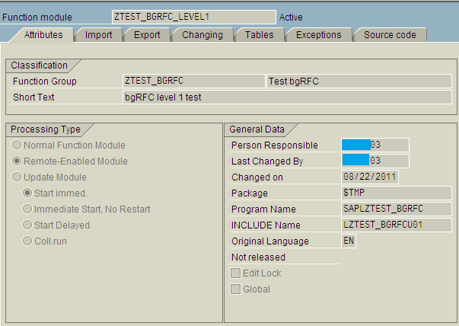
The function module must be RFC enabled function module.
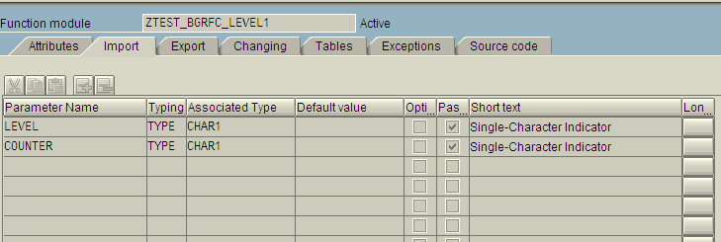
Here one thing needs to be remembered, calling the function module will happen once program does the COMMIT WORK. If we want to create bgRFC from our custom program like report in that case we have to do external COMMIT WORK but if we are trying to create bgRFC from any BADI/USER EXIT/Enhancement Spot in that case we do not need to apply external COMMIT WORK. Once standard SAP do the COMMIT WORK bgRFC unit will be created.

iv) bgRFC Debugging
1. Debug bgRFC unit using external break points: This is the most common way to debug a bgRFC unit. We have to put one external break point in the bgRFC unit to debug the unit. In the above demonstrated example we have to put external break point in the function module code to debug the logic of the function module. Any session break point will not work. In the below screen shot external break point is set inside the calling function module.
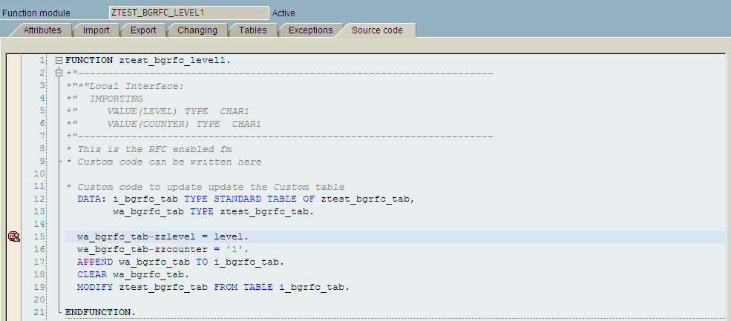
2. Debug bgRFC unit with bgRFC Monitor: This is another option to debug any bgRFC unit. This is generally used if any created unit is failed, in that case we can debug the particular unit using bgRFC Monitor. We have to use transaction SBGRFCMON to monitor the bgRFC units. Monitoring bgRFC units will be discussed in detail after this. To debug a particular erroneous unit we have to position the cursor on the unit in question and choose Unit Analysis ® Debug Unit from the context menu. There are some prerequisites to debug bgRFC unit this transaction.
- The user creating the bgRFC and the user carrying out debugging must both have the new debugger set at the time of debugging.
- Units can only be debugged directly with the bgRFC monitor if they have the status red (contain errors) or yellow (locked). Units with status green (error-free and not locked) cannot be debugged with the bgRFC Monitor.
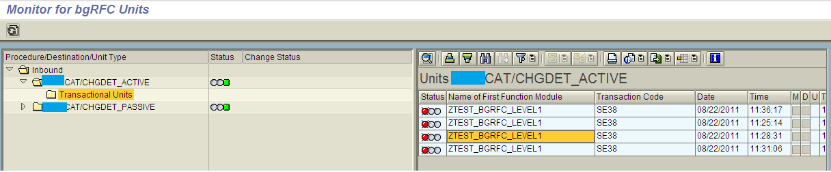
In this example we have to put cursor on the particular unit and right click then choose Unit Analysis -> Debug Unit. If we cannot find this option in the context menu, this means that we are not authorized to carry out debugging with the bgRFC monitor.
  - bgRFC Monitoring
This is the last topic we will discuss in this document. bgRFC monitor typically required to check if any unit is failed or there are any issues in any particular unit.
We have to use transaction SBGRFCMON to monitor bgRFC unit. In the selection screen we have option to monitor Inbound/Outbound unit along with tRFC unit or qRFC unit. Also there are several options in the selection screen. Please refer the below screen shot.
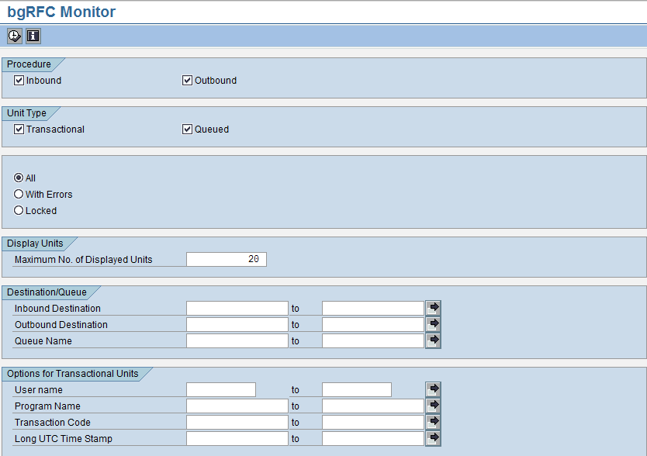

After executing the transaction we will be able to monitor all the erroneous units in the system. We have to remember if any unit is created successfully and if there are no data issue or any connection issue in that case it will be executed and we will not able to see it in this transaction. Only erroneous and warning units will be displayed here. Please refer the below screenshot.
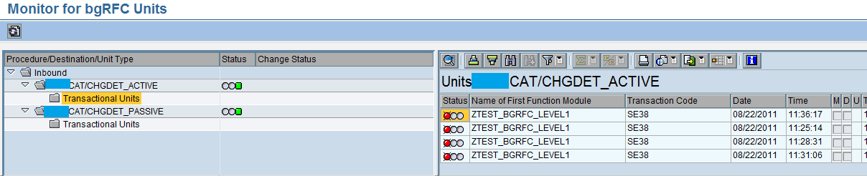
If we want to restart any units in that case put cursor in the desired unit then right click and select Restart Unit.
We can also monitor bgRFC unit using transaction SBGRFCPERFMON. Please refer the below screenshot for reference.
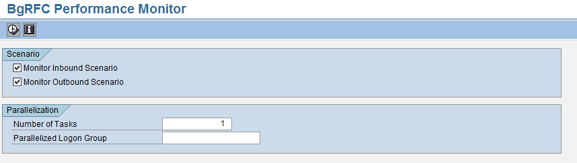After executing this transaction we can monitor how many units are ready to execute, total no of units etc.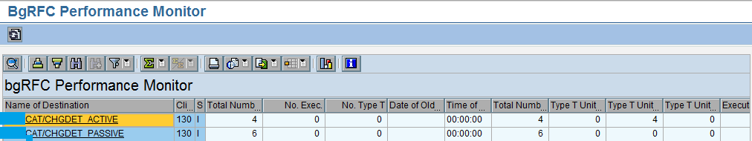
If we select any Destination then will be able see all the units of that destination. This is the same view as we see using transaction SBGRFCMON.
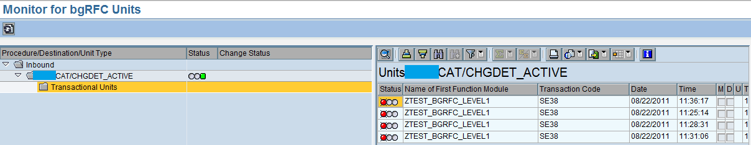
References:
http://help.sap.com/saphelp_nw73ehp1/helpdata/en/48/9709f255493987e10000000a421937/content.htm Configuration
http://help.sap.com/saphelp_nw73ehp1/helpdata/en/48/929142aa6b17cee10000000a421937/content.htm Programming
http://help.sap.com/saphelp_nw70/helpdata/en/44/f6f232f60b41e2e10000000a1553f6/content.htm Monitor
https://help.sap.com/saphelp_nwpi711/helpdata/en/48/927cd3aa6b17cee10000000a421937/content.htm Debugging

